ICMC2026 Hamburg

Music Presentation Template

Title
Subtitle

Abstract
The abstract should be placed at the start and should not exceed 500 words. The abstract should be formatted in italic type. All submissions must be in English and use appropriate and inclusive language. Please remove any identifying information from your submission materials to ensure a double-blind peer review process. Non-anonymized submissions will be excluded from the reviewing process.

Introduction
This template includes all the information about formatting music proposals for the ICMC 2026 Conference. Please use MS-Office template when preparing your submission. Please follow these guidelines to give the final proceedings a uniform look. Authors will be required to make any necessary typographic corrections and changes before publication. If you have any questions, please contact the ICMC 2026 Organizers.

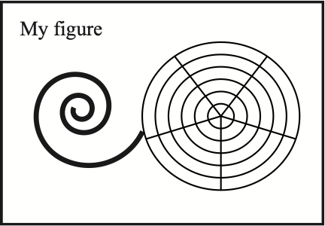
Figure 1. Figure captions should be placed below the figure, exactly like this. Please note that the printed proceedings will be black and white.

